Import the dataset

import pandas as pd

import numpy as np

data=pd.read_csv("dataset_website.csv")

data

**index having_IPhaving_IP_Address URLURL_Length Shortining_Service having_At_Symbol double_slash_redirecting Prefix_Suffix having_Sub_Domain SSLfinal_State Domain_registeration_length ... popUpWidnow Iframe age_of_domain DNSRecord web_traffic Page_Rank Google_Index Links_pointing_to_page Statistical_report Result**

0 1 -1 1 1 1 -1 -1 -1 -1 -1 ... 1 1 -1 -1 -1 -1 1 1 -1 -1

1 2 1 1 1 1 1 -1 0 1 -1 ... 1 1 -1 -1 0 -1 1 1 1 -1

2 3 1 0 1 1 1 -1 -1 -1 -1 ... 1 1 1 -1 1 -1 1 0 -1 -1

3 4 1 0 1 1 1 -1 -1 -1 1 ... 1 1 -1 -1 1 -1 1 -1 1 -1

4 5 1 0 -1 1 1 -1 1 1 -1 ... -1 1 -1 -1 0 -1 1 1 1 1

... ... ... ... ... ... ... ... ... ... ... ... ... ... ... ... ... ... ... ... ... ...

11050 11051 1 -1 1 -1 1 1 1 1 -1 ... -1 -1 1 1 -1 -1 1 1 1 1

11051 11052 -1 1 1 -1 -1 -1 1 -1 -1 ... -1 1 1 1 1 1 1 -1 1 -1

11052 11053 1 -1 1 1 1 -1 1 -1 -1 ... 1 1 1 1 1 -1 1 0 1 -1

11053 11054 -1 -1 1

**11055 rows × 32 columns**

data.head()

index having_IPhaving_IP_Address URLURL_Length Shortining_Service having_At_Symbol double_slash_redirecting Prefix_Suffix having_Sub_Domain SSLfinal_State Domain_registeration_length ... popUpWidnow Iframe age_of_domain DNSRecord web_traffic Page_Rank Google_Index Links_pointing_to_page Statistical_report Result

0 1 -1 1 1 1 -1 -1 -1 -1 -1 ... 1 1 -1 -1 -1 -1 1 1 -1 -1

1 2 1 1 1 1 1 -1 0 1 -1 ... 1 1 -1 -1 0 -1 1 1 1 -1

2 3 1 0 1 1 1 -1 -1 -1 -1 ... 1 1 1 -1 1 -1 1 0 -1 -1

3 4 1 0 1 1 1 -1 -1 -1 1 ... 1 1 -1 -1 1 -1 1 -1 1 -1

4 5 1 0 -1 1 1 -1 1 1 -1 ... -1 1 -1 -1 0 -1 1 1 1 1

**5 rows × 32 columns**

**Numerical analysis:**

data**.**shape

(11055, 32)

data**.**size

353760

data**.**info()

RangeIndex: 11055 entries, 0 to 11054

Data columns (total 32 columns):

# Column Non-Null Count Dtype

--- ------ -------------- -----

0 index 11055 non-null int64

1 having_IPhaving_IP_Address 11055 non-null int64

2 URLURL_Length 11055 non-null int64

3 Shortining_Service 11055 non-null int64

4 having_At_Symbol 11055 non-null int64

5 double_slash_redirecting 11055 non-null int64

6 Prefix_Suffix 11055 non-null int64

7 having_Sub_Domain 11055 non-null int64

8 SSLfinal_State 11055 non-null int64

9 Domain_registeration_length 11055 non-null int64

10 Favicon 11055 non-null int64

11 port 11055 non-null int64

12 HTTPS_token 11055 non-null int64

13 Request_URL 11055 non-null int64

14 URL_of_Anchor 11055 non-null int64

15 Links_in_tags 11055 non-null int64

16 SFH 11055 non-null int64

17 Submitting_to_email 11055 non-null int64

18 Abnormal_URL 11055 non-null int64

19 Redirect 11055 non-null int64

20 on_mouseover 11055 non-null int64

21 RightClick 11055 non-null int64

22 popUpWidnow 11055 non-null int64

23 Iframe 11055 non-null int64

24 age_of_domain 11055 non-null int64

25 DNSRecord 11055 non-null int64

26 web_traffic 11055 non-null int64

27 Page_Rank 11055 non-null int64

28 Google_Index 11055 non-null int64

29 Links_pointing_to_page 11055 non-null int64

30 Statistical_report 11055 non-null int64

31 Result 11055 non-null int64

dtypes: int64(32)

memory usage: 2.7 MB

data**.**describe()

**index having_IPhaving_IP_Address URLURL_Length Shortining_Service having_At_Symbol double_slash_redirecting Prefix_Suffix having_Sub_Domain SSLfinal_State Domain_registeration_length ... popUpWidnow Iframe age_of_domain DNSRecord web_traffic Page_Rank Google_Index Links_pointing_to_page Statistical_report Result**

count 11055.000000 11055.000000 11055.000000 11055.000000 11055.000000 11055.000000 11055.000000 11055.000000 11055.000000 11055.000000 ... 11055.000000 11055.000000 11055.000000 11055.000000 11055.000000 11055.000000 11055.000000 11055.000000 11055.000000 11055.000000

mean 5528.000000 0.313795 -0.633198 0.738761 0.700588 0.741474 -0.734962 0.063953 0.250927 -0.336771 ... 0.613388 0.816915 0.061239 0.377114 0.287291 -0.483673 0.721574 0.344007 0.719584 0.113885

std 3191.447947 0.949534 0.766095 0.673998 0.713598 0.671011 0.678139 0.817518 0.911892 0.941629 ... 0.789818 0.576784 0.998168 0.926209 0.827733 0.875289 0.692369 0.569944 0.694437 0.993539

min 1.000000 -1.000000 -1.000000 -1.000000 -1.000000 -1.000000 -1.000000 -1.000000 -1.000000 -1.000000 ... -1.000000 -1.000000 -1.000000 -1.000000 -1.000000 -1.000000 -1.000000 -1.000000 -1.000000 -1.000000

25% 2764.500000 -1.000000 -1.000000 1.000000 1.000000 1.000000 -1.000000 -1.000000 -1.000000 -1.000000 ... 1.000000 1.000000 -1.000000 -1.000000 0.000000 -1.000000 1.000000 0.000000 1.000000 -1.000000

50% 5528.000000 1.000000 -1.000000 1.000000 1.000000 1.000000 -1.000000 0.000000 1.000000 -1.000000 ... 1.000000 1.000000 1.000000 1.000000 1.000000 -1.000000 1.000000 0.000000 1.000000 1.000000

75% 8291.500000 1.000000 -1.000000 1.000000 1.000000 1.000000 -1.000000 1.000000 1.000000 1.000000 ... 1.000000 1.000000 1.000000 1.000000 1.000000 1.000000 1.000000 1.000000 1.000000 1.000000

max 11055.000000 1.000000 1.000000 1.000000 1.000000 1.000000 1.000000 1.000000 1.000000 1.000000 ... 1.000000 1.000000 1.000000 1.000000 1.000000 1.000000 1.000000 1.000000 1.000000 1.000000

8 rows × 32 columns

**Handling Null Values**

**Checking for Null values in a dataset and handling if any**

ata**.**isnull()**.**any()

index False

having_IPhaving_IP_Address False

URLURL_Length False

Shortining_Service False

having_At_Symbol False

double_slash_redirecting False

Prefix_Suffix False

having_Sub_Domain False

SSLfinal_State False

Domain_registeration_length False

Favicon False

port False

HTTPS_token False

Request_URL False

URL_of_Anchor False

Links_in_tags False

SFH False

Submitting_to_email False

Abnormal_URL False

Redirect False

on_mouseover False

RightClick False

popUpWidnow False

Iframe False

age_of_domain False

DNSRecord False

web_traffic False

Page_Rank False

Google_Index False

Links_pointing_to_page False

Statistical_report False

Result False

dtype: bool

In [11]:

data**.**isnull()**.**sum()

index 0

having_IPhaving_IP_Address 0

URLURL_Length 0

Shortining_Service 0

having_At_Symbol 0

double_slash_redirecting 0

Prefix_Suffix 0

having_Sub_Domain 0

SSLfinal_State 0

Domain_registeration_length 0

Favicon 0

port 0

HTTPS_token 0

Request_URL 0

URL_of_Anchor 0

Links_in_tags 0

SFH 0

Submitting_to_email 0

Abnormal_URL 0

Redirect 0

on_mouseover 0

RightClick 0

popUpWidnow 0

Iframe 0

age_of_domain 0

DNSRecord 0

web_traffic 0

Page_Rank 0

Google_Index 0

Links_pointing_to_page 0

Statistical_report 0

Result 0

dtype: int64

**Data Visualization**

**import** matplotlib.pyplot **as** plt

**import** seaborn **as** sns

**def** plot_corr(df,size**=**10):

corr**=**df**.**corr()

fig,ax**=**plt**.**subplots(figsize**=**(size,size))

ax**.**legend()

cax**=**ax**.**matshow(corr)

fig**.**colorbar(cax)

plt**.**xticks(range(len(corr**.**columns)), corr**.**columns, rotation**=**'vertical')

plt**.**yticks(range(len(corr**.**columns)), corr**.**columns)

plot_corr(data)

No handles with labels found to put in legend.

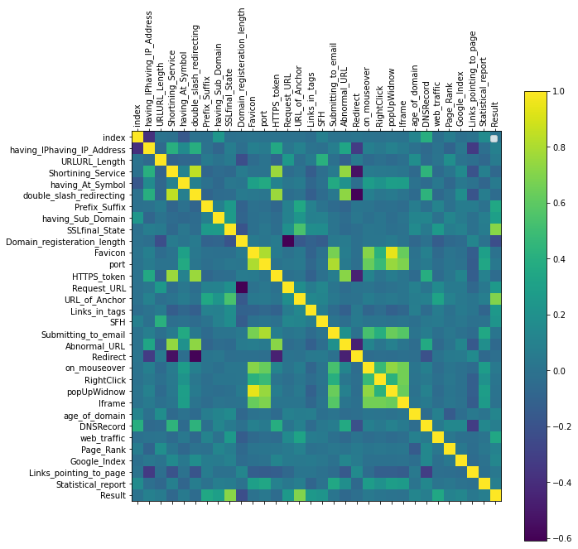

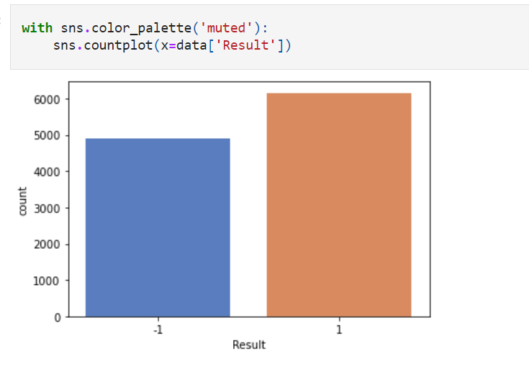

**Splitting The Data:**

x**=**data**.**iloc[:,1:31]**.**values

y**=**data**.**iloc[:,**-**1]**.**values

print(x)

[[-1 1 1 ... 1 1 -1]

[ 1 1 1 ... 1 1 1]

[ 1 0 1 ... 1 0 -1]

...

[ 1 -1 1 ... 1 0 1]

[-1 -1 1 ... 1 1 1]

[-1 -1 1 ... -1 1 -1]]

print(y)

[-1 -1 -1 ... -1 -1 -1]

**Splitting data into train and test:**

**from** sklearn.model_selection **import** train_test_split

x_train,x_test,y_train,y_test**=**train_test_split(x,y,test_size**=**0.2,random_state**=**0)

x_train**.**shape

(8844, 30)

y_train**.**shape

(8844,)

x_test**.**shape

(2211, 30)

y_test**.**shape

(2211,)